Wavyleaf Basketgrass, our newest invader!
Tom McAvoy, RATC Conservation Supervisor and Claire Krotoski, Non-Native Invasive Species Coordinator
Wavyleaf basketgrass, (Oplismenus undulatifolius) is a rapidly spreading invasive plant which is capable of dominating forest understories. It was first found in Maryland in 1996 and is a native of southeastern Europe. Basketgrass alters habitats, displaces native plants, and reduces pollinator populations. It has been recently found along the AT just north of the James River, Carvins Cove, Northern and Central Virginia.
Description: Leaves are between 0.5 and 1.0 inches wide and 1.5-4 inches long. The leaves have a distinct 'rippled' appearance, which earns the name 'wavyleaf.' Stems are short, low-creeping, 8–11 inches tall, but may reach 18 inches tall, and grow in dense carpets. Seeds mature in late summer.
WHAT TO DO IF YOU SEE IT?
Get a Photo! So experts can verify the identification.
Get a Location! If you have a handheld GPS or phone, please record the exact location of the plant. If you cannot, record detailed information on the location of the plant
Record the Date & Amount! In square feet
Report Your Sighting! Please send your photos, coordinates, and location descriptions to ckrotoski@appalachiantrail.org or conservationsupervisor@ratc.org
Prevention is Key! Seeds are designed to stick to your boots and clothes! After a hike inspect and clean your boots of any seeds that may have stuck to you on the trail. Stick to the trail as much as possible. Spread the word!
Thank you for your help!
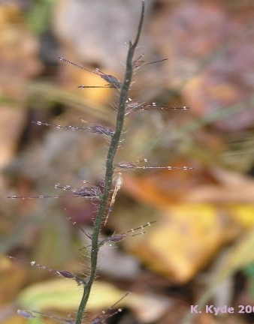
Wavyleaf basketgrass seeds
Wavyleaf basketgrass leaves
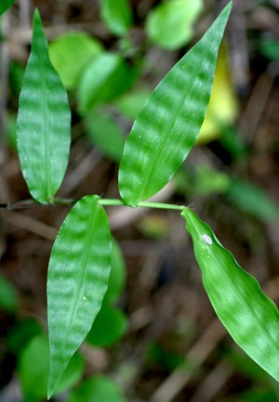
Wavyleaf basketgrass leaves

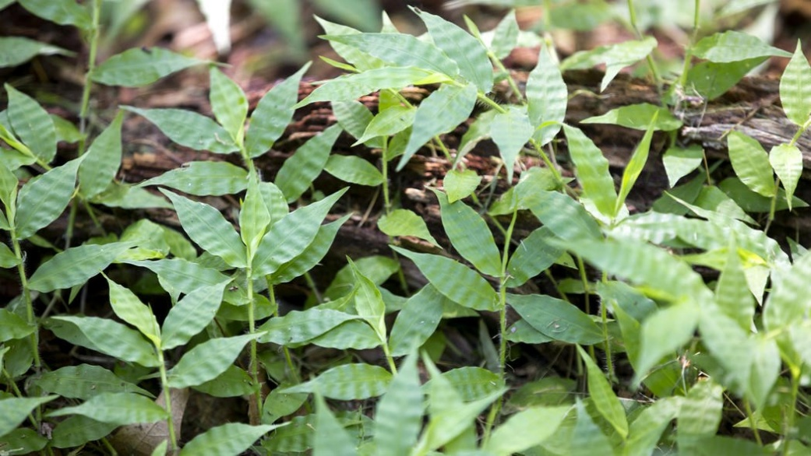
Wavyleaf basketgrass leavesseeds

